**Week 13-01:**

**Name:Snehan.S**

**Roll no:241801272**

**1.** Given an array of numbers, find the index of the smallest array element (the pivot), for which the sums of all elements to the left and to the right are equal. The array may not be reordered.

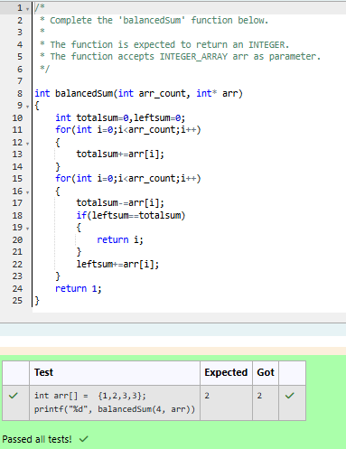

2. Calculate the sum of an array of integers

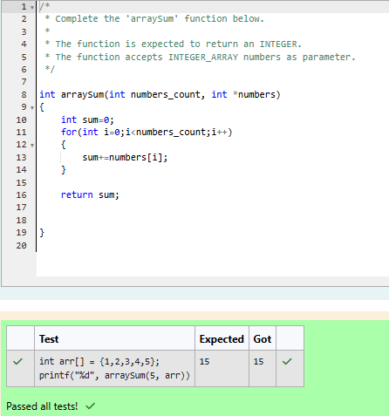

3. Given an array of n integers, rearrange them so that the sum of the absolute differences of all adjacent elements is minimized. Then, compute the sum of those absolute differences.

